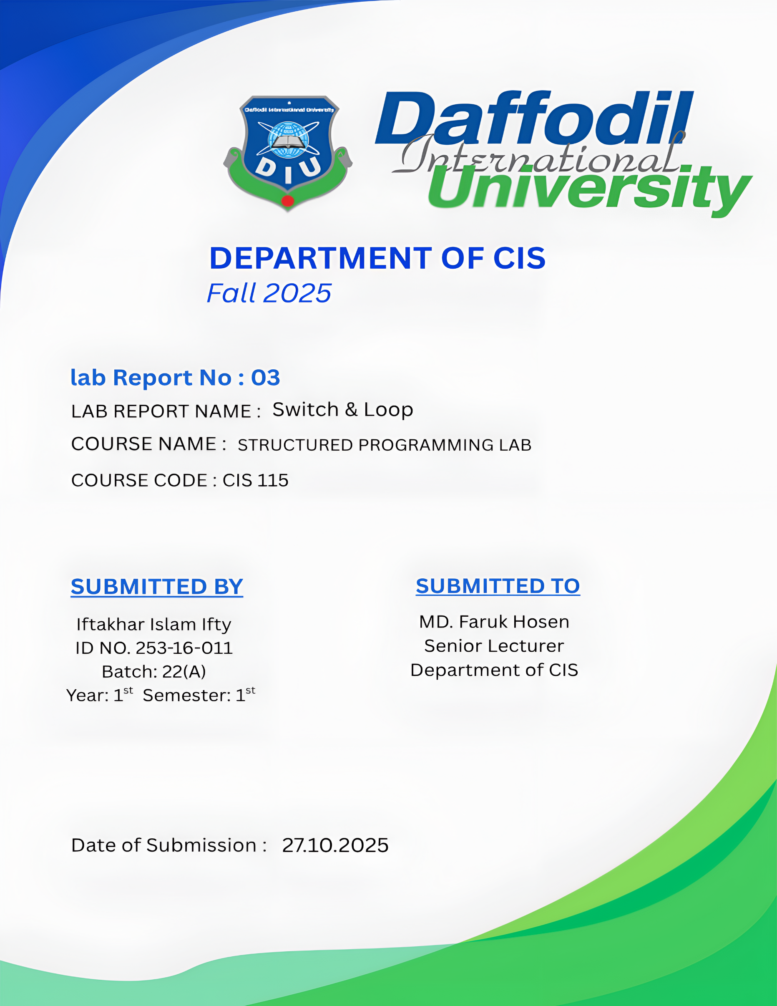

Switch

Problem No: 01
Problem Name: Write a program that reads a digit and displays its spelling.

Source Code:
#include <stdio.h>
int main() {
int digit;
printf("Enter a digit (0-9): ");
scanf("%d", &digit);

switch(digit) {
case 0: printf("Zero"); break;
case 1: printf("One"); break;
case 2: printf("Two"); break;
case 3: printf("Three"); break;
case 4: printf("Four"); break;
case 5: printf("Five"); break;
case 6: printf("Six"); break;
case 7: printf("Seven"); break;
case 8: printf("Eight"); break;
case 9: printf("Nine"); break;
default: printf("Note a vaild digit!");
}
return 0;
}

Output :

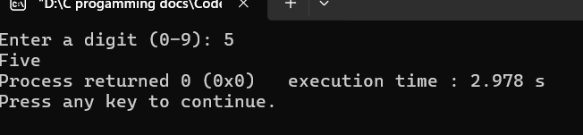

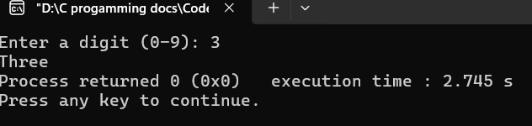

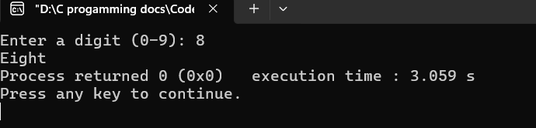

Problem No: 02
Problem Name: Write a Program that reads any number and displays its Roman
equivalent.

Source Code:
#include <stdio.h>
int main() {
int num;

printf("Enter a num (1-5): ");
scanf("%d", &num);

switch(num) {
case 1: printf("I"); break;
case 2: printf("II"); break;
case 3: printf("III"); break;
case 4: printf("IV"); break;
case 5: printf("V"); break;
default: printf("Number out of range!");

}
return 0;
}

Output :

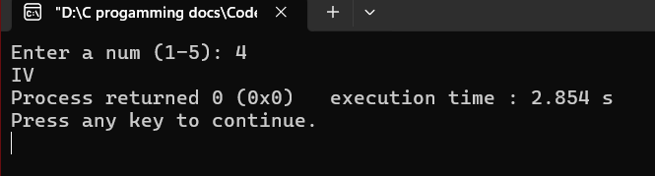

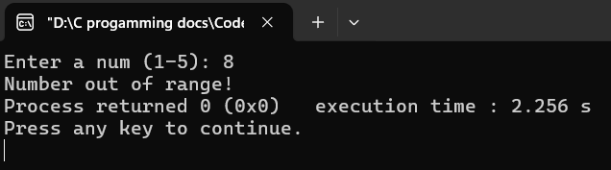

Loop

Problem No: 01
Problem Name: Write a program that read a positive integer and display its
factorial.

Source Code:
#include <stdio.h>
int main() {
int n , i;
long long factorial = 1;
printf("Enter a positive integer: ");
scanf("%d", &n);

for(i = 1; i <= n; i++)
{ factorial = factorial * i;}
printf("Factorial of %d = %llu", n, factorial);
return 0;
}

Output :
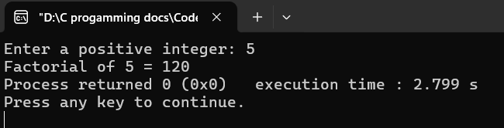
Problem No: 02
Problem Name: Write a program that read any positive integer and display sum of
its digit.

Source Code:
#include <stdio.h>
int main() {
int n , sum = 0, remainder;

printf("Enter a positive integer: ");
scanf("%d", &n);

while(n != 0){
remainder = n% 10;
sum = sum + remainder;
n = n/10;
}
printf("Sum of digits = %d", sum);

return 0;
}

Output :
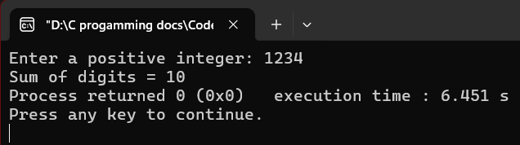
Problem No: 03
Problem Name: Write a program that read any positive integer and display reverse.

Source Code:
#include <stdio.h>
int main() {
int n , reversed = 0, remainder;

printf("Enter a positive integer: ");
scanf("%d", &n);

while(n != 0){
remainder = n% 10;
reversed = reversed * 10 + remainder;
n = n/10;
}
printf("Reversed number = %d", reversed);
return 0;
}

Output :

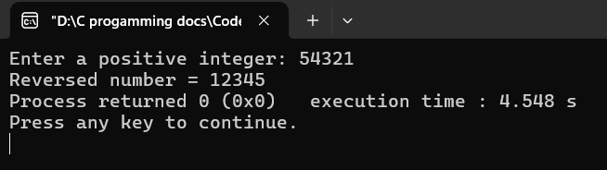
Problem No: 04
Problem Name: Write a program that read any decimal number and display
equivalent binary number

Source Code:
#include <stdio.h>
int main() {
int n , binary[32], i = 0;

printf("Enter a decimal number: ");
scanf("%d", &n);

while(n > 0){
binary[i] = n % 2;
n = n /2;
i++;
}
printf("binary number: ");
for(int j = i - 1; j >= 0; j--){
printf("%d", binary[j]);
}
return 0;
}

Output :
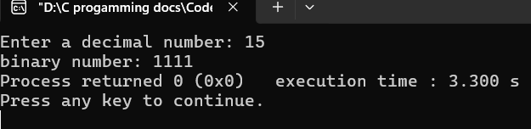
Problem No: 05
Problem Name: Write a program that read any decimal number and display
equivalent octal number.

Source Code:
#include <stdio.h>
int main() {
int n , octal[32], i = 0;

printf("Enter a decimal number: ");
scanf("%d", &n);

while(n > 0){
octal[i] = n % 8;
n = n /8 ;
i++;
}
printf("octal number: ");
for(int j = i - 1; j >= 0; j--){
printf("%d", octal[j]);
}
return 0;
}

Output :
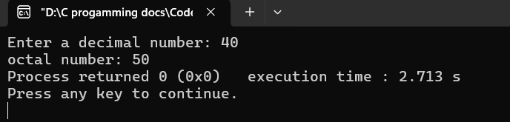

Problem No: 06
Problem Name: Write a program that read any decimal number and display
equivalent hexadecimal number.

Source Code:
#include <stdio.h>
int main() {
int n , i = 0;
char hex[32];

printf("Enter a decimal number: ");
scanf("%d", &n);
while(n > 0) {
int remainder = n % 16;
if (remainder < 10) {
hex[i] = remainder + '0';
} else {
hex[i] = remainder - 10 + 'A';
}
n = n / 16;
i++;
}
printf("Hexadecimal number: ");
for(int j = i - 1; j >= 0; j--){
printf("%c", hex[j]);
}
return 0;
}

Output :
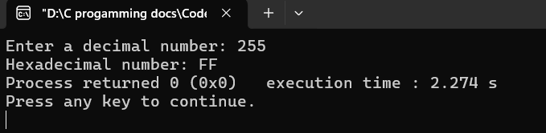

Problem No: 07
Problem Name: Write a program that read two numbers and display GCD
(greatest common divisor).

Source Code:
#include <stdio.h>
int main() {
int x, y, gcd;

printf("Enter two number: ");
scanf("%d %d", &x, &y);

while(y != 0){
int temp = y;
y = x % y;
x = temp;
}
gcd = x;
printf("GCD = %d\n", gcd);
return 0;
}

Output :
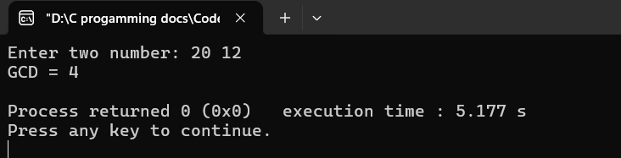
Problem No: 08
Problem Name: Write a program that read two numbers and display LCM
(least common multiple).

Source Code:
#include <stdio.h>
int main() {
int x, y, temp1, temp2, gcd, lcm;

printf("Enter two number: ");
scanf("%d %d", &x, &y);
temp1 = x;
temp2 = y;

while(y != 0){
int temp = y;
y = x % y;
x = temp; }
gcd = x;
lcm = (temp1 * temp2) / gcd;

printf("LCM = %d\n", lcm);
return 0;
}

Output :
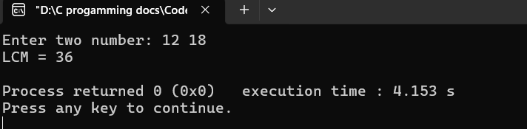
Problem No: 09
Problem Name: Write a program that read two numbers (x, y) and display
x^y (x to the power y).

Source Code:
#include <stdio.h>
#include <stdlib.h>
int main(){
int x, y, result = 1;

printf("Enter base and power: ");
scanf("%d %d", &x, &y);

for (int i = 1; i <= y; i++ ){
result = result * x;
}

printf("%d^%d = %d\n", x, y, result);
return 0;
}

Output :
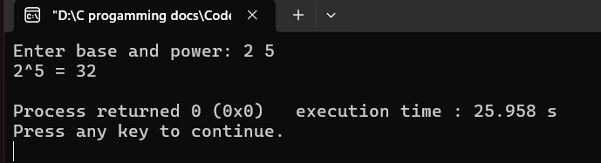

Problem No: 10
Problem Name: Write a program that read any integer and its digital root.

Source Code:
#include <stdio.h>
int main() {
int main() {
int n, sum = 0;

printf("Enter any integer: ");
scanf("%d", &n);

while (n > 9) {
sum = 0;
while (n > 0) {
sum = sum + (n % 10);
n = n / 10; }
n = sum; }
printf("Digital Root = %d\n", n);
return 0;
}

Output :
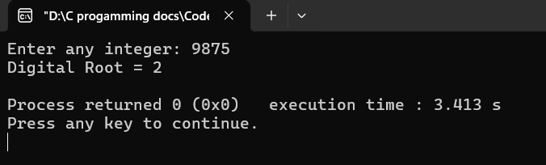
Problem No: 11
Problem Name: Write a program that read any integer and test prime or not prime.

Source Code:
#include <stdio.h>
int main() {
int n, i = 2, isPrime = 1;

printf("Enter any integer: ");
scanf("%d", &n);

if (n <= 1) {
isPrime = 0;
} else {
while (i <= n / 2) {
if (n % i == 0) {
isPrime = 0;
break; }
i++;
}
}

if (isPrime == 1)
printf("%d is a Prime number\n", n);
else
printf("%d is not a Prime number\n", n);
return 0;
}

Output :
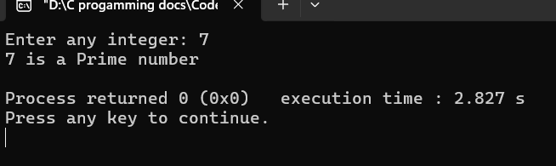

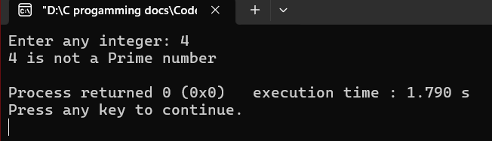

Problem No: 12
Problem Name: Write a program that print all prime numbers from 1 to n.

Source Code:
#include <stdio.h>
#include <stdlib.h>
int main(){
int n, i, j, isprime;

printf("Enter n: ");
scanf("%d", &n);
printf("Prime number from 1 to %d are:\n", n);

for(i = 2; i <= n; i++){
isprime = 1;
for(j = 2; j <= i/2; j++){
if (i % j == 0) {
isprime = 0;
break; } }
if (isprime == 1)
printf(" %d", i); }
return 0;
}

Output :
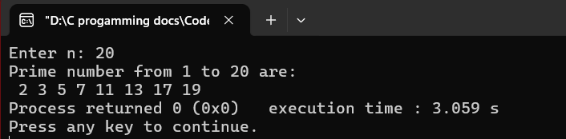
Problem No: 13
Problem Name: Write a program that print all prime numbers from m to
n (m > n).

Source Code:
#include <stdio.h>
#include <stdlib.h>
int main(){
int m, n, i, j, isPrime;

printf("Enter m greater number: ");
scanf("%d", &m);
printf("Enter n smaller number: ");
scanf("%d", &n);

printf("Prime numbers from %d to %d are:\n", m, n);

for (i = m; i >= n; i--) {
if (i < 2)
continue;
isPrime = 1;
for (j = 2; j <= i / 2; j++) {
if (i % j == 0) {
isPrime = 0;
break;
} }
if (isPrime == 1)
printf(" %d", i);
}
return 0;
}
Output :
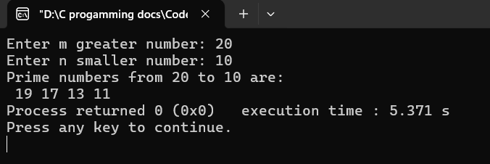

Problem No: 14
Problem Name: Write a program that count total prime numbers from 1 to n.

Source Code:
#include <stdio.h>
#include <stdlib.h>

int main(){
int n, i, j, isPrime, count = 0;

printf("Enter n: ");
scanf("%d", &n);

for (i = 2; i <= n; i++) {
isPrime = 1;
for (j = 2; j <= i / 2; j++) {
if (i % j == 0) {
isPrime = 0;
break;
}
}
if (isPrime == 1)
count++;
}
printf("Total prime number from 1 to %d = %d\n", n, count);
return 0;
}

Output :

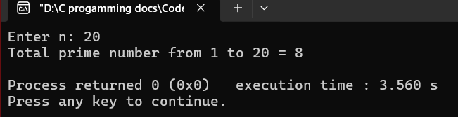

Problem No: 15
Problem Name: Write a program that displays first n prime numbers.

Source Code:
#include <stdio.h>
int main() {
int n, i = 2, count = 0, j, isPrime;

printf("Enter how many prime numbers to display: ");
scanf("%d", &n);

printf("First %d prime numbers are:\n", n);

while (count < n) {
isPrime = 1;
for (j = 2; j <= i / 2; j++) {
if (i % j == 0) {
isPrime = 0;
break;
}
}
if (isPrime == 1) {
printf("%d ", i);
count++;
}
i++;
}
return 0;
}

Output :
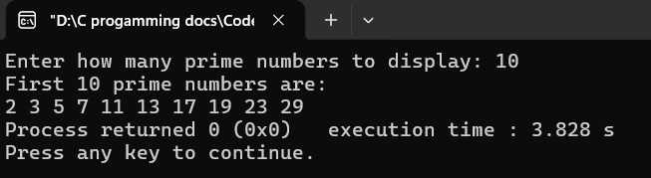

Problem No: 16
Problem Name: Write a program that print first n Fibonacci numbers.

Source Code:
#include <stdio.h>
#include <stdlib.h>

int main() {
int n, first = 0, second = 1, next, i;

printf("Enter Fibonacci numbers: ");
scanf("%d", &n);
printf("First %d Fibonacci numbers are:\n", n);

for (i = 1; i <= n; i++) {
printf("%d ", first);
next = first + second;
first = second;
second = next;
}
return 0;
}

Output :
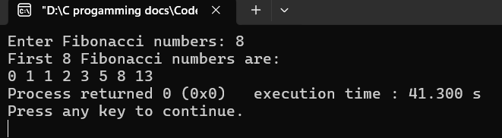
Problem No: 17
Problem Name: Write a program that prints all Fibonacci numbers from 1 to n.

Source Code:
#include <stdio.h>
#include <stdlib.h>
int main() {
int n, first = 0, second = 1, next = 0;

printf("Enter the range (n): ");
scanf("%d", &n);
printf("First %d Fibonacci numbers are:\n", n);

while (first <= n) {
printf("%d ", first);
next = first + second;
first = second;
second = next;
}
return 0;
}

Output :
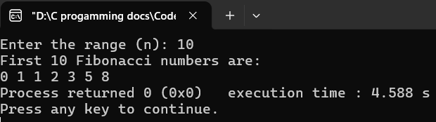
Problem No: 18
Problem Name: Write a program that a number Fibonacci or not Fibonacci.

Source Code:
#include <stdio.h>
#include <stdlib.h>

int main() {
int n, first = 0, second = 1, next = 0, isFibo = 0;

printf("Enter a number: ");
scanf("%d", &n);

while (next <= n) {
if (next == n) {
isFibo = 1;
break;
}
next = first + second;
first = second;
second = next;
}
if (isFibo == 1)
printf("%d is a Fibonacci number\n", n);
else
printf("%d is NOT a Fibonacci number\n", n);

return 0;
}
Output :

